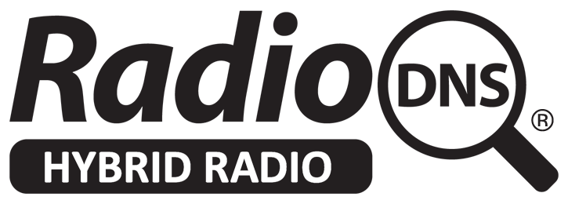

SB66/4 - Minutes for the 66th Steering Board

Tuesday 8th April 2025

11:00 ET / 16:00 BST / 17:00 CET

## 

# **Attendees**

Neil BINGHAM (Frontier) (Secretary)  
Laurence HARRISON (Radioplayer)

Rosie KENDRICK (RadioDNS)

David LAYER (NAB)

Nick PIGGOTT (RadioDNS Project Director)

Ben POOR (EBU) (Chair)

Michael REICHERT (ARD)

Nacho Seirul-Lo SALAS (NXP)

Jamie SAMPSON (iHeartMedia)

Dave WALTERS (BBC) (part)

Christian WINTER (CARIAD)

# **Apologies**

Badri MUNIPALLA (NPR)

# **Minutes**

1. Welcome and Introductions, including introducing new Chair, Ben Poor.
2. Agenda approved
3. Minutes of the [65th Steering Board](https://docs.google.com/document/d/1E0h3KKp8-D5QzCxdzGivWztlsIdmYsNoGchN5zBtAMI/edit?usp=drive_link) approved.
4. Action Points Review
   1. PO to do comms activity around updates to ETSI standards - to do
   2. NP to create job description for support/admin role - to do
   3. NP to create a non-tech accessible blog-post on the technical group activities - [published](https://radiodns.org/news-events/news/2025/02/11/what-does-the-radiodns-technology-group-do/)
   4. NP to create changelogs for the standards documents - TS 102 818 has been done, no additional ones since last meeting
   5. NP and RK to update coverage map online and get some topline figures - awaiting go live of FQDN project
   6. Work with TG to work out their objectives for 2025 - see Technical Group report
   7. NP and BP to ask TG regarding assisting broadcasters on implementation and getting this information to a bigger audience - see Technical Group report
   8. Contact Paul McLane / Nick Langam re article in Radioworld re TG activities - NP met Nick Langam at NAB.
5. Technical Group Report (SB66/2)  
   All meeting time has been spent on progressing the on-demand audio / linking to broadcaster apps, update from NP on potentially giving guidance about what happens in different scenarios, and being more specific about directions. NP said he has already made improvements when using the demo at NAB.  
   Other projects have been put on hold whilst this has taken up most of the meeting time.
6. Project Office Report (SB66/3)  
   NP updated on accounts and membership fees outstanding.  
   RK updated on past events and planned events. BP added that WorldDAB has a big presence at IBC so maybe we could work with them. MR said that ARD has a stand and networking event at IAA and to speak to him about it.

**AP - RK to talk to MR and WorldDAB about IAA and IBC.**  
NP updated on demo receiver, links to videos in PO report which demonstrate the journey from broadcast radio and the broadcaster app.  
NSLS asked which app it chooses, NP replied the radio station picks which app it offers for install, the radio knows which platform it is running on and so installs that one, referenced by the station in their own SI file.  
JS asked what the next step is for the design and process into the vehicle. NP replied it was built as an experience to see the functionality and has additionally helped iron out some of the user flow, but it isn’t a product that can be bought from RadioDNS.  
DW gave a positive response and asked what the feedback has been from the floor at NAB. NP replied that those who knew about RadioDNS have been impressed at how simple and fluid it is, those that don’t know about RadioDNS, it has been one of the things that has hooked people in (the other being correct logos) DW added that this could be made into a video and gets put on socials.  
**AP - NP to create a video of the demo that can be used on our socials.**BP said he is hoping to demo this to broadcasters through the EBU, adding it can be used to promote the app eco-system.DL said one of the goals of the demo was to create a ‘demo kit’ for others to make. NP replied that this is still the intention and anyone who has made a demo model will continue to get updates.Wrong radio stations logos project is progressing with a paper prototype but nothing to show.  
LH asked about the FQDN timeline, NP replied that it is ready to go, but needs to now be transferred and is now top priority. LH also said some of their clients have received comms from RadioDNS about a global service, NP asked to see those comms.

DW asked if there is a reset function as part of the value is to see how things get installed. NP replied that there isn’t an easy "single button" solution but will look into it.

1. Any Other Business  
   **AP - Steering Board to think of an additional board member and nominate them. NP clarified they don’t need to be from a member organisation. Email NP with any suggestions.**DL asked LH about the Radioplayer experience at NAB. LH said it’s the same demo as at Radiodays and he is happy to share the experience with the group after NAB, he continued that their demo and RadioDNS demo are aligned. Initial feedback from car manufacturers is there is interest in the feature and makes the link between broadcast and app environments.